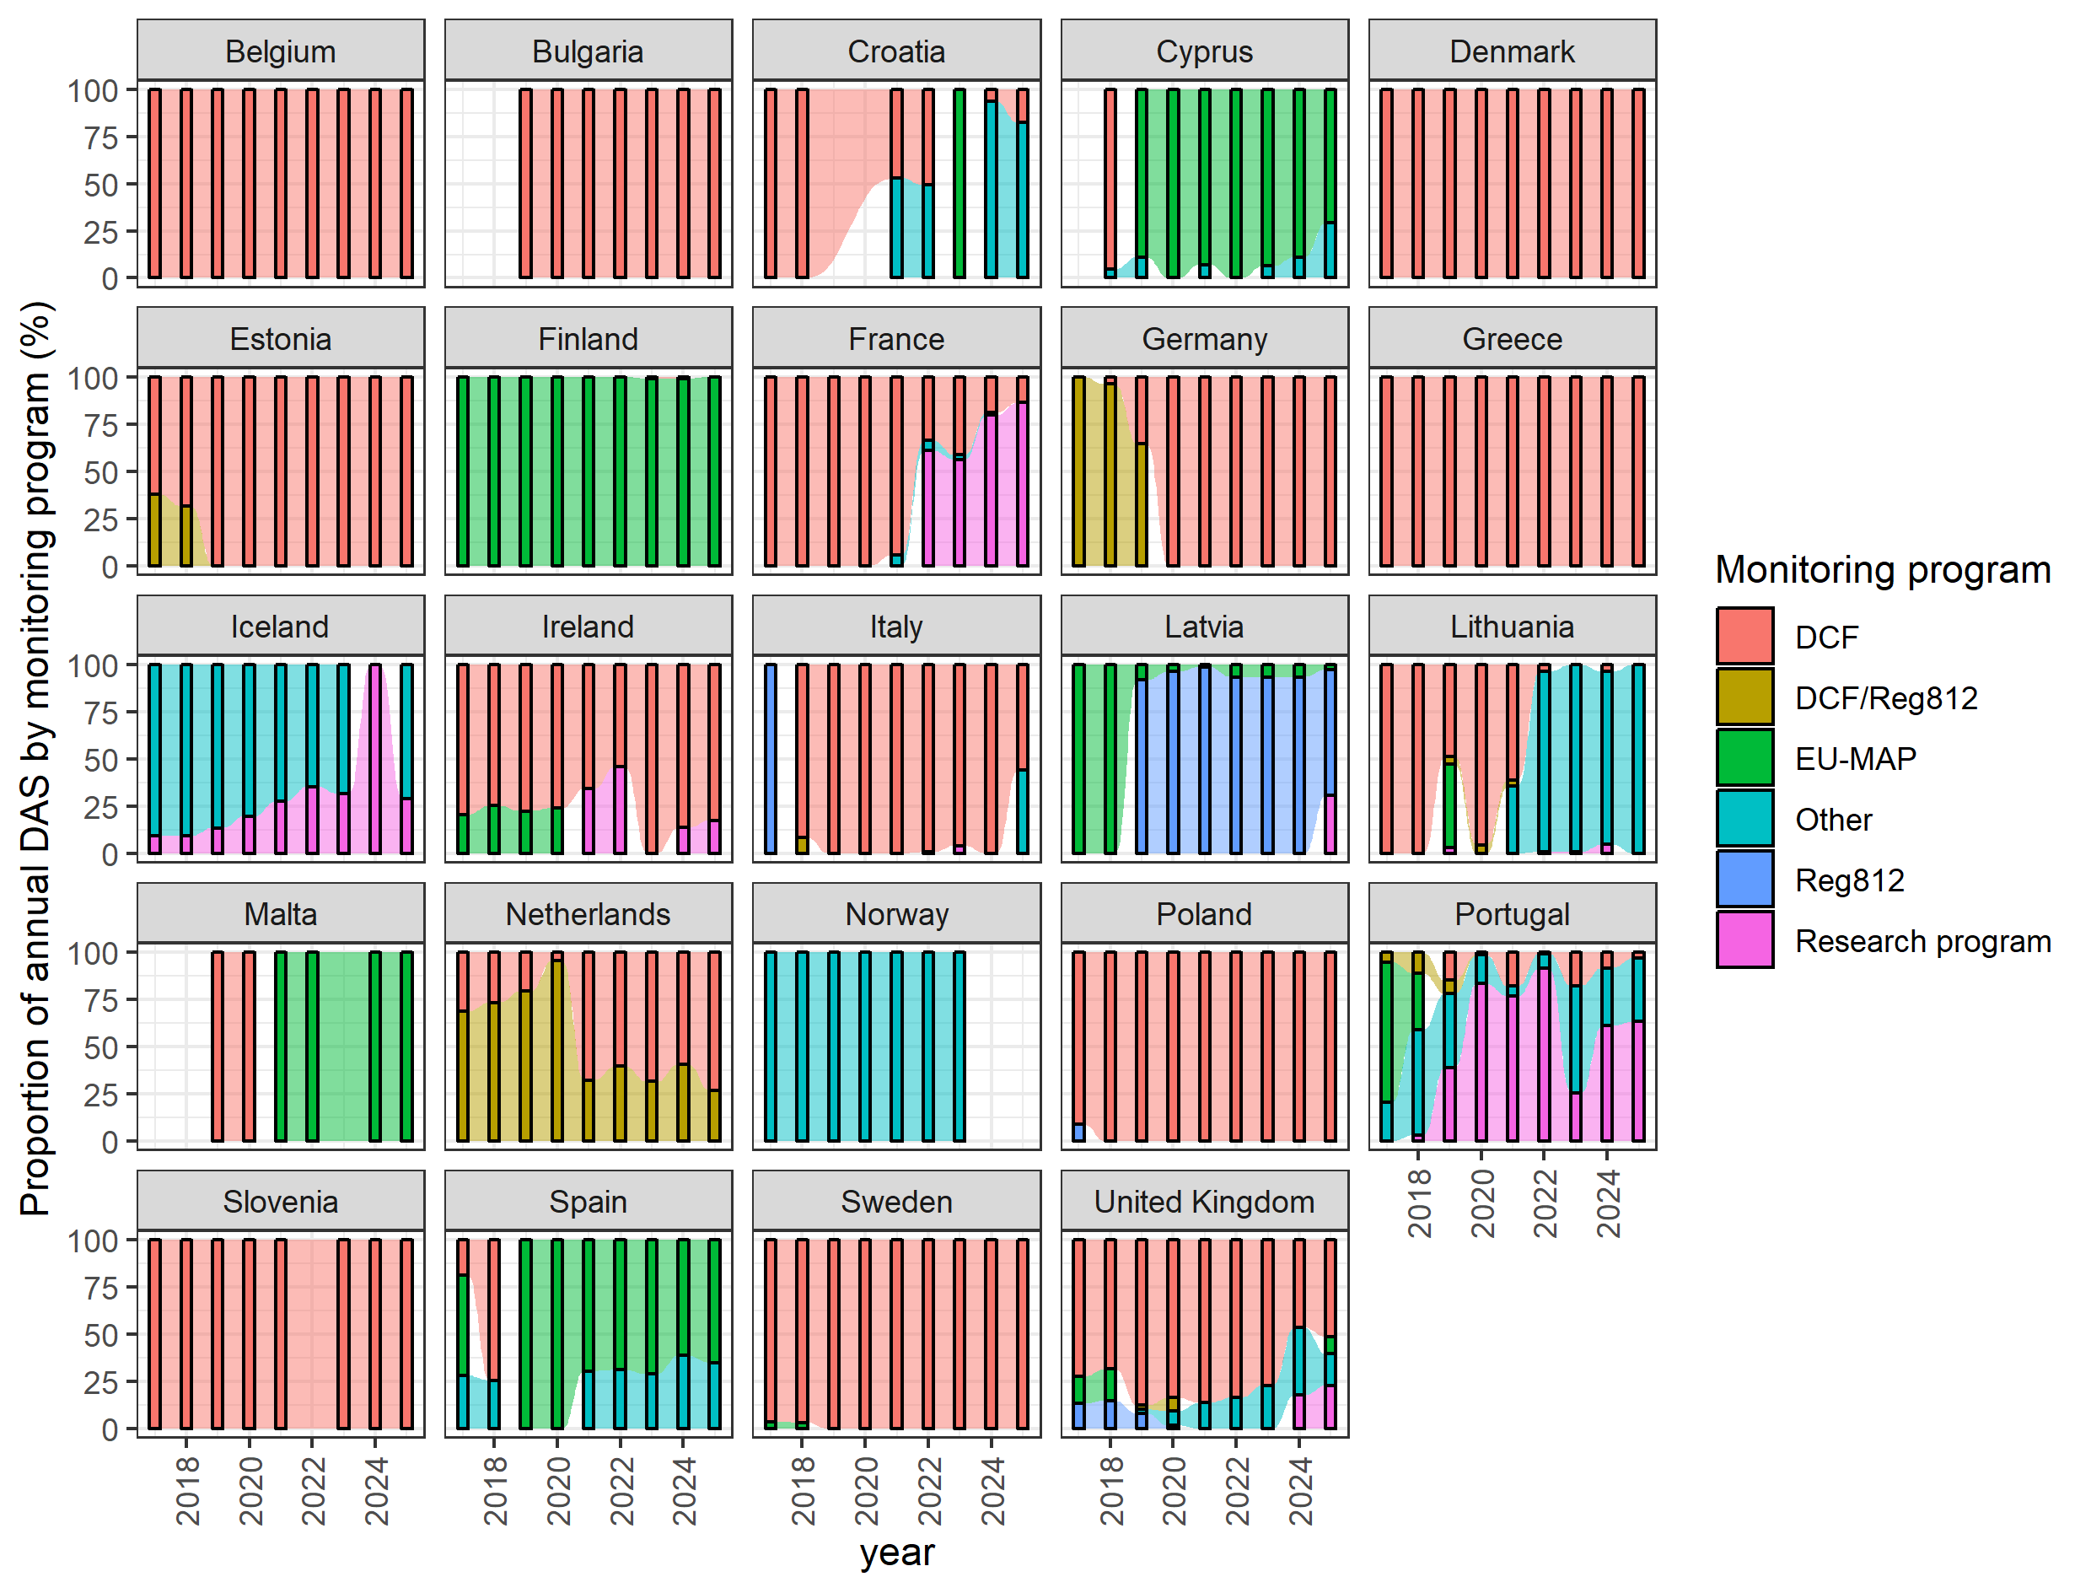
Total monitored (observed) days at sea reported by each country for each monitoring program (2017-2025)

